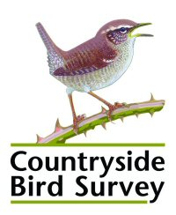 | Data Request Form  -  Countryside Bird Survey (CBS)

Please read the accompanying notes on the Countryside Bird Survey (CBS) before completing this form. Ensure all parts of the form are completed. Please check that you have signed the form, indicating that you agree to the terms and conditions of the data use.
Organisation: | Contact name:
Address:
  Position:
  Telephone:
  Email:

Project Details
Title:
Please give details of the data you require (continue on separate sheet if necessary).
In what capacity are you carrying out this work? |  | Amateur Professional Student
Is the work part of a commercial study? |  | Yes No
Are you receiving external funding? |  | Yes No
If yes, please specify the source of funding:
Please give details of your study, including location, the analyses, timeline and plans for publication (expand textbox if necessary).
Please give details of the data you require (expand textbox if necessary).
In what form do you wish to receive the data? (please check that the data you request are available).
Have you made a significant contribution to the gathering of these data? |  |  | Yes No
I confirm that all information given here is correct. I agree to abide by the conditions of data use (see attached Guidance Notes) and understand that these Guidance Notes and this completed Data Request Form taken together form the basis of a legally binding contract with the CBS partners (National Parks & Wildlife Service and BirdWatch Ireland).

Signature ……………………………………………..………….. Date …………………………...…………

