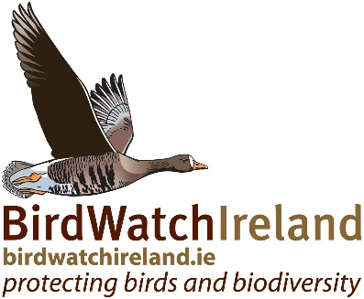

BirdWatch Ireland Seasonal Posts 2025 – Swift Fieldworker x 2

Job Vacancies:
Two seasonal Swift Fieldworkers (subject to funding) available between May/June - August.
- Fingal 1 full time post
- Cavan 1 post either full time or part time 3 days a week

Salary
Will be determined following outcome of project bid process.

Background
BirdWatch Ireland is Ireland’s largest conservation charity concerned with the protection of birds and biodiversity. A key part of our conservation work for urban birds has been to survey and carry out conservation actions for breeding Swifts in collaboration with local county councils and community groups.
In Ireland Swifts are Red listed on the Birds of Conservation Concern, due to declines in their breeding population. Within Europe they are now classified as “Near Threatened” with extinction.
The County Swift Projects aim to record and quantify the level of Swift nesting activity in selected towns and villages. It will identify where nesting Swift populations are found and highlight where urgent conservation action is needed. The survey team will make a special effort to include local community groups and residents in the project, to help establish a local network of Swift champions in each area.
Job Description
- Carry out Swift surveys in selected towns/villages to locate Swift populations and nest sites.
- Input data in a timely and accurate manor to the Swift survey portal, ensuring that all data held in the portal is up to date an accurate on project completion.
- Identify and mark nesting sites on photos (taken in the field) as they are located and according to established formatting guidelines.
- Identify threats to nesting Swift in each town/village.
- Identify suitable locations for the erection of nest boxes in each town/village.
- Survey existing Swift nest boxes for nesting activity, where required.
- Establish connections and liaise with individuals and community groups to help establish a network of local Swift champions.
- Carry out field visits and provide advice and guidance to local individuals or groups on Swift ecology and conservation.
- Assist with the completion of the interim and final report, as required.
- Create tables of nest sites according to established guidelines, for both the interim and final report.
- Assist in the orginisation and carry out public events, including swift walks and presentations, as required.

Essential Criteria
- A degree in biology or related discipline or previous proven experience working on conservation projects/ecological surveys
- Previous experience of bird survey work
- Ability to work flexible hours, including early morning and / or late evenings and weekends, on occasion.
- Experience using excel.
- Ability to compile data, analyse results and write reports.
- A full driver’s licence and business car insurance.
- Previous experience of lone working
- Excellent communication skills

Desirable Criteria
- Experience carrying out Swift surveys
- Excellent bird identification skills
- Experience liaising with or working with community groups
- Experience working in urban environments
- Ability to edit photos in the field
- Experience using bird survey portals
- Experience carrying out presentations or workshops
- Experience using GIS or QGIS
- Previous experience implementing health and safety measures in relation to loan working or working in urban areas.

How to Apply
Please download and complete a BirdWatch Ireland application form here.
Applicants who wish to apply for both positions should rank their order of preference.
When submitting applications by email, please put the job title of the position you are applying for in the subject line. If you are applying for both positions, please enter both positions in the subject line.
Closing date for applications: Monday 28th April at 9:00am. Interviews are likely to be conducted the following week.
Applications, or queries, can be emailed to recruitment@birdwatchireland.ie.

